1 Here are some common circuit symbols

[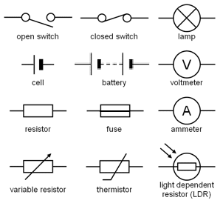](http://www.google.ie/url?sa=i&rct=j&q=&esrc=s&source=images&cd=&cad=rja&uact=8&ved=0ahUKEwiWrp7hsqLJAhWFvxQKHawDBMUQjRwIBw&url=http://www.frankswebspace.org.uk/ScienceAndMaths/physics/physicsGCSE/circuitSymbols.htm&psig=AFQjCNE7bIXsZCaTYvfro8ruqd0soCLiaw&ust=1448225294770884)

[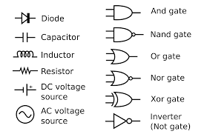](http://www.google.ie/imgres?imgurl=https://upload.wikimedia.org/wikipedia/commons/thumb/c/cb/Circuit_elements.svg/2000px-Circuit_elements.svg.png&imgrefurl=https://en.wikipedia.org/wiki/Electronic_symbol&h=1300&w=2000&tbnid=H0HVFZqSkpzDWM:&docid=gKMX-6La3yTrpM&ei=jthQVvy9HcPpPraytcgD&tbm=isch&ved=0ahUKEwj8vJDjsaLJAhXDtA8KHTZZDTkQMwghKAEwAQ)

http://www.talkingelectronics.com/CctSymbols/Circuit_Symbols.html

2 Here are some things we can use to make a circuit.

BreadBoard

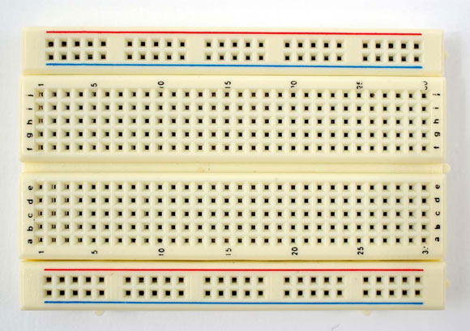

A breadboard is a re-useable platform for mounting components. Consisting of a number of small holes that are actually connected underneath in various lines, they create the circuit connections when you push components into them, thereby avoiding the need for soldering and allowing you to experiment with ease

This breadboard has two areas, the central parts and a outer parts. The two rows in the Outer parts are connected ***horizontally***, and is usually used a common connection for +VCC or GND.

In the Central parts the connections are ***vertical.*** This is where you usually make your circuits. To make a circuit you will normally connect to another hole in a **different** row.

Jumperwires

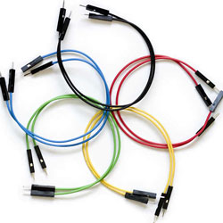

For making connections within your breadboard (to a different physical area) and to the Arduino itself, jumper wires are used. These are just bits of wire with fixed ends that can be stuck into the Arduino and plugs on the breadboard.

Resistors

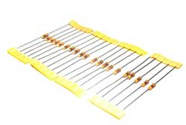

Resistors limit the flow of current to other components. The main reason for doing this is to protect other components from damage. See our separate Sushi card on Resistors for more information.

LED’s

[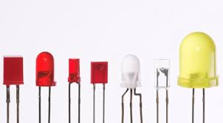](http://www.google.ie/imgres?imgurl=http://www.extremetech.com/wp-content/uploads/2013/02/a-variety-of-LEDs1-640x353.jpg&imgrefurl=http://www.extremetech.com/extreme/147339-micro-led-lifi-where-every-light-source-in-the-world-is-also-tv-and-provides-gigabit-internet-access&h=353&w=640&tbnid=GNFlR7ddtvZ9PM:&docid=_rlaaI21rmWGAM&ei=a-BQVpnQOcXrPvyQnpgH&tbm=isch&ved=0ahUKEwjZsZyjuaLJAhXFtQ8KHXyIB3MQMwhUKC4wLg)

Light Emitting Diodes emit light when you supply them with power! Just make sure you use a resistor with them in your circuit. LEDs have both a positive and a negative leg. The negative must be connected to the ground (GND), the shorter of the two legs, or by a flat indentation in the head of the LED.

3 Lets make our first circuit with some of these components

[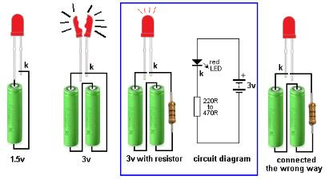](http://www.google.ie/url?sa=i&rct=j&q=&esrc=s&source=images&cd=&cad=rja&uact=8&ved=0ahUKEwj1jsLpuqLJAhUCwBQKHT0wD6IQjRwIBw&url=http://www.ebah.com.br/content/ABAAAfXO0AI/led-projects-eletronica&psig=AFQjCNFgY1WSp7X9d8olX9iNeWflDL__6w&ust=1448227638773352)

Some important information to note:

The + (positive) pole of the battery has the bit that sticks up and is sometimes called the anode, the – (negative) pole of the battery is flag and is sometimes called the cathode.

Electricity always flows from the + to the –

Batteries are usually connected in Series, when connected this way you add up the combined Voltages to get the total – e.g. two 1.5v Batteries will give you 3v.

The longer arm of the LED should be connected to the + supply, the LED will not work if connected round the wrong way – a common problem when you are first starting out.

A resistor is added to reduce the current to the component. Too much current can cause the component to overheat and be damaged. Certain components only operated with a current within a certain range, and we use resistors of different values to adjust the current.